# Image Classification using CNN

**Members**

* Mugheera Bin Sadiq 18K-0296
* Yusha Arif 18K-1289
* Abdul Musawwir Siddiqui K180185

1. **Project Motivation**

* Image classification based on their classes is easy for humans but difficult for machines. We plan to train a model on many images from various classes to build a model for prediction.

1. **Problem Definition/Structure**

* Data set: Cifar-10 image data
* Input: Images of random classes, out of 10.
* Output: Class Label
* The shape of train and test data
* (50000, 32, 32, 3) (50000, 10)
* (10000, 32, 32, 3) (10000, 10)

1. **Relevant Method/Model**

Out basic task is to create an algorithm to classify image using CNN into the dataset classes. We have used the Convolutional neural networks architecture for training the model using Keras. We have also added dropout to reduce the overfitting of the model.

1. **Performance Measurement**

* Cross Entropy Loss function is used to evaluate the performance of the model.
* We expect the minimum accuracy of 90% on testing data

1. **Risks and Dependencies**

* Preprocessing of data should be done.
* Dependent on GPU, for running epochs with better speed.

1. **Run Performance Checks**

* 92% Accuracy on Testing data
* Confusion Matrix

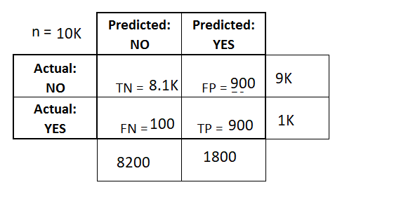

**ABSTRACT**

In this project, we plan to develop an architecture for classifying images of 10 different classes like automobile, airplanes and birds. We investigated the deep neural networks to address this problem. We used the Convolutional Neural networks (CNN) to extract and learn features of the images and train our model for classification. We tried various experiments to improve the accuracy on our test dataset and finally achieved an accuracy of 92% by this approach. We used the RELU and Softmax as the activation functions.

**INTRODUCTION**

1. **Overview**

The rise of big data and popularizing of high computing devices have contributed to the development of machine learning. Image classification is one of the important topics in the field of machine learning. This project involves artificial extraction of features using the Sequential model and training the model to classify and predict the class of a new input image.

1. **Motivation**

Image classification based on their classes is easy for humans but difficult for machines. We plan to train a model on many images from various classes to build a model for prediction.

1. **Approach**

Our basic task is to create an architecture to classify image into the dataset classes. We have used the Convolutional neural networks algorithm for training the model using keras. Our architecture is based on convolutions, pooling layers and dropout.

1. **Dataset**

We have used the Cifar-10 dataset. It is a public dataset made available by the University of Toronto and it can be downloaded from [1]. The dataset contains images belonging to 10 classes. The dataset has been split in 90% training set and 10% testing set and have used for generating results by feature extraction and labels.

**BACKGROUND**

Many projects have been previously done in the field of Image classification using CNN. We studied various previous research papers and learned to modify our model to increase accuracy and performance. Alex Krizhevsky and Ilya Sutskever [2] published a paper to suggest using multiple layers and adding regularizes to improve accuracy. Also, adding dropout would help in reducing overfitting and improving accuracy. We then applied dropout to our model and the accuracy of the model increased to 92%.

**METHODS AND MATERIALS**

**Architecture of the Model**

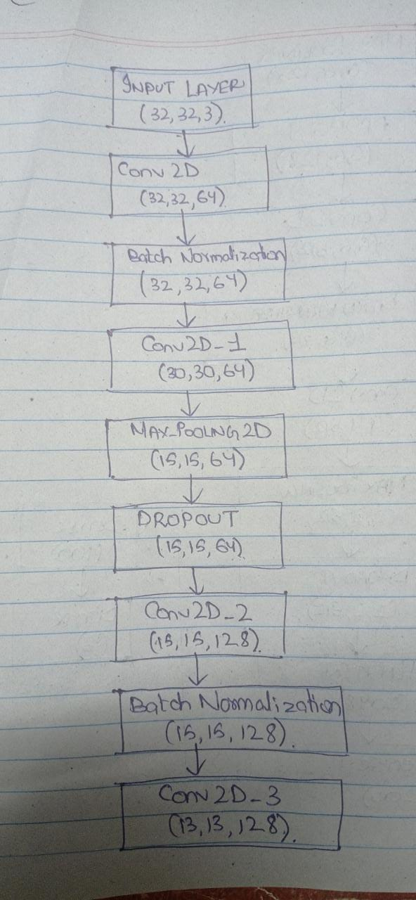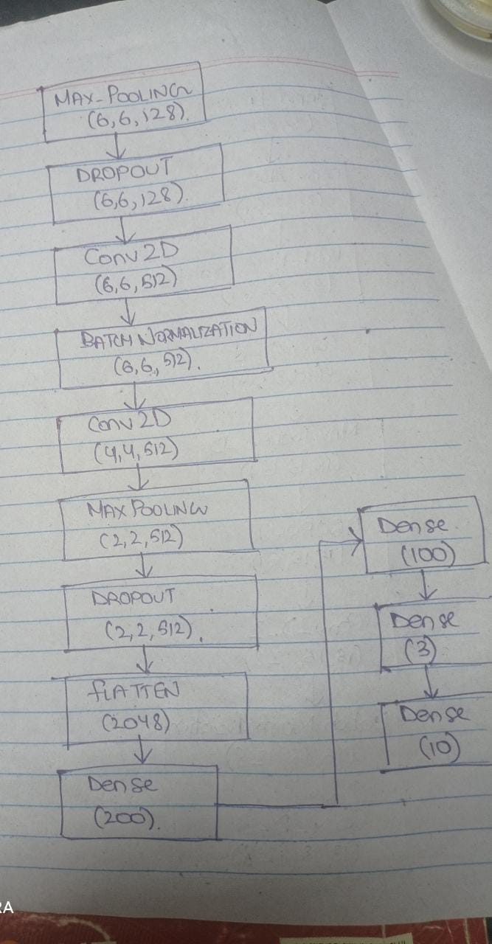

1. Importing the required libraries and helper functions.
2. Load Data
   1. Importing the CIFAR-10 dataset.
3. Pre-process Data
4. Visualize Samples
   1. Plotting randomly selected examples of a given set.
   2. We look at some examples from training and test set along with their labels.
5. Create the Model
   1. Creating a Keras Sequential model.
   2. Creating a function to add a convolutional block to the model.
   3. A look at the model summary.
6. Train the Model
7. Final Predictions
   1. Plotting the training and validation accuracy from the training.
   2. Getting predictions on the test set and displaying the results.
8. Evaluating the model

**DATA AND RESULTS**

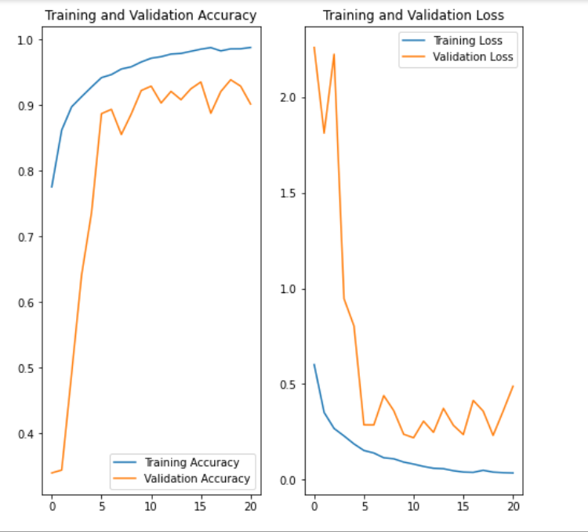

* 98% accuracy on Training dataset,
* 92% accuracy on Testing dataset.

**CONCLUSION**

* Increasing the number of convolution layers in a fully connected model helped us increase accuracy of the model. Dropouts, Batch Normalization helps to reduce the overfitting of the model.
* We achieved the accuracy of **92%** on the Testing data set and **98%** percent accuracy on Training data.
* CIFAR-10 data set is used to train the model which contains the total of 60,000 images which belongs to 10 different classes.
* This model is only trained for the images which belong to the following classes.
* Airplane
* Automobile
* Bird
* Cat
* Deer
* Dog
* Frog
* Horse
* Ship
* Truck
* The model is trained for the mutually exclusively images. The model is not capable of identifying those images which contains overlapping objects.

**REFRENCES**

[1]<https://www.cs.toronto.edu/~kriz/cifar.html#:~:text=The%20CIFAR%2D10%20dataset,with%206000%20images%20per%20class.&text=The%20dataset%20is%20divided%20into,selected%20images%20from%20each%20class>

[2] “ImageNet Classification with Deep Convolutional Neural Networks.” Alex Krizhevsky and Ilya Sutskever.